
Shahba_88@yahoo.co.in
+91 9920427895
Architect Shahba Khan

Professional qualification
COA REGISTRATION NO. : CA/2012/56400
Carbonspace architecture and design
Year 2010 – till present
Terra ventures pvt.ltd.
Current position : senior architect

Work Details

Projects
Mixed used projects Land Development Project Management
individual residence hospitality
Educational Building industrial building
façade development

Responsibilities and work skills
Concepts details execution
3d views presentation
Site survey site visits boq
Client Co-ordination
Strong design Skills Graphic Design Sense Material Research
Leading a team of architects
Software skills
Revit Sketch up Autocad Adobe photoshop msoffice

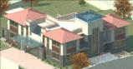

Professional projects
- punjani bungalow, lonavla
- laskari bungalow, alibaug
- patil house, alibaug
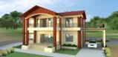
- sunbird villa, alibaug
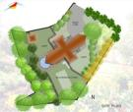
- baldawala bungalow, alibaug
- patel villa, daman
- tank villa, daman
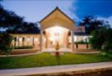
- garments factory, daman
- project phoenix, kankavli
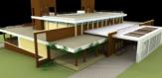
- btc resource centre,badlapur
- sterling seaface, worli
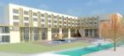
- terra heavens, alibaug
- vinod adani, lonavla
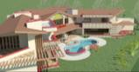
- holiday home scheme, daman
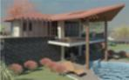
- 5 star hotel, daman
- chawla development, panvel
- golf club & resort, karjat
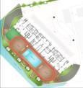
- Bharat bijlee, kalwa
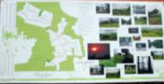
- Residential scheme, Gujarat
- Suparna villa, alibaug
- Luxury villa scheme, lonavla
- Puri studio house, lonavla

Academic projects
Design dissertation: Military aviation museum, Mumbai
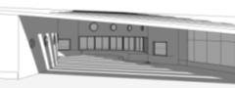
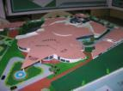

Educational qualification

b.arch. first class i.e.s.college of
2011 mumbai university architecture

hsc distinction s.i.w.s college
2006 maharashtra board

ssc distinction olgc high school
2004 maharashtra board

Extracurricular achievements

- was an active member in organizing annual college festival “avartan'08,’09,’10”
- won various intercollege dance, dramatic, drawing & sports events
- participated in nasa reubens trophy ‘08

Personal details
Name : shahba shamim khan
Address : 404, b-21, amrit anand chs ltd,
sector 11, shantinagar, mira road (east) thane-401 107 maharashtra.

Date of birth : 02-09-1988 gender: female
Languages known : English Hindi Marathi
Other skills : analytical, team facilitator, hard
worker, keen and enthusiastic to learn

I hereby declare that the information furnished above is true to the best of my knowledge.

Shahba Khan

